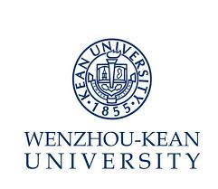
Job Description – – CNCC Course Instructor & Admin II (Course: Inheritance and Internationalization of Chinese Culture)

Department: Chinese Curricula Center Reports to: Associate Director(CNCC)

Position Summary

- Assist in establishing CNCC curriculum, assist in organizing the teaching;
- Formulate teaching plans, course outlines and instruct on course Inheritance and Internationalization of Chinese Culture and responsible for the relative research work;
- Provide students with developmental suggestions according to timely evaluation;
- Responsible for teaching Chinese and Chinese culture to speakers of other languages;
- Complete other work assigned by superiors.

Qualification:
- Master or above, major in Chinese language or related;
- CET 6 or above or strong English writing and speaking ability, strong teaching and certain research ability.

Preferred Qualification:
- With at least three years relative teaching experience in Sino-foreign higher education institutions.

岗位书 – 文化教学与管理II 《文化传承与国际化》
部门：国情中心 汇报：文化教学与管理副主任
岗位职责：
（1）协助建设国情与文化教育体系，协助国情与文化教学组织；
（2）制定《文化传承与国际化》教学大纲，承担课程教学及相关科研；
(3) 对学生进行定期考核和评估，并给出一定发展建议；
（4）负责对外汉语及文化教学；
（5）完成交办的其他相关工作。

聘任条件：
必备条件
（1） 硕士及以上学位，中国语言文学类专业；
（2） 大学英语六级以上或流利英文书面及口头表达能力，较强教学能力，一定科研能力。
优先条件
（1） 具备3年以上中外合作高校相关教学经历。

