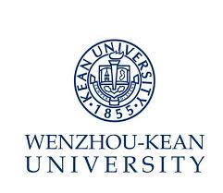
Job Description – Human Resources Specialist (For Recruitment)

Department: Human Resources Office

Report to: Director of Human Resources
Position Summary
- Be responsible to expand recruitment channels. Establish and maintain the cooperating relationship in the long term.
- Be responsible to maintain the recruitment system and the candidate pool.
- Assist to follow up each department/college’s hiring procedure.
- Assist to deal with international recruitment related issues.
- Assist to establish and improve recruitment and selection policies.
- Assist to deal with other department tasks when necessary.

Qualification

- Master’s degree (or above) from Human Resources or Marketing relative majors.
- Two years (or more) of professional work experience in relative areas.
- Honest, careful and diligent.
- Competitive capability in communication and coordination.

Preferred Qualification

- Oversea education background or work experience.
- Excellent oral and writing English.

岗位书 – 人事专员(招聘方向)
部门：人力资源部 汇报：人力资源部主任
岗位职责：
- 负责拓展和维护各招聘渠道；
- 负责招聘系统的维护和人才库的建立；
- 协助跟进和对接各部门/学院的招聘进程；
- 协助完成国际招聘相关事宜；
- 协助制定或完善各类招聘与甄选相关政策；
- 在需要时，协助部门内的其他各项任务。

聘任条件：
必备条件
- 硕士及以上学位，人力资源或市场营销等相关专业；
- 至少2年相关工作经验；
- 坚持原则，廉洁奉公，专心细心；
- 有较强的组织、协调能力。
优先条件
- 有海外留学、相关工作背景者优先考虑；
- 具备优秀的英语书面及口语表达能力者优先考虑。

