**NOTICE OF DISCLAIMER**

The policies and procedures contained in this handbook are for informational purposes only and are subject to change. Since this handbook is subject to change, it is the faculty members’ responsibility to refer to the current version and to be knowledgeable of the revised policies and procedures. This handbook is a general guide to Wenzhou-Kean University’s current policies, procedures. It is for informational purposes only, and is not intended to be and should not be construed as a contract, or an implied contract, of employment.

# TABLE OF CONTENTS

TABLE OF CONTENTS 2

➢ EMPLOYMENT INFORMATION 4

Search Committee 4

Position Review Process 4

Selection Procedures 4

Appointment Letter 5

Multi-year Contract 6

Tenure Policy 6

Onboarding Preparation 7

Orientation and Work/Residence Permit 7

Over Retirement Age 8

Religious Activity 8

Resignation and Dismissal 8

➢ SALARY AND BENEFITS 10

Salary Determination 10

Salary Increases 10

Benefits 10

Retirement Compensation 12

Health Insurance 12

Leave & Attendance Policy 12

Tuition Discount 13

➢ PAYROLL 14

Currency and Exchange Rate 14

Pay Periods and Dates 14

Individual Income Tax 14

Direct Deposit 15

Pay Stub 15

Conversion and Wire Transfer 15

➢ HOUSING 16

Moving In 16

Management Rules 16

Moving Apartment 17

Moving Out 17

➢ ACADEMIC AFFAIRS 20

Library 20

Textbook Acquisition Service 21

Research and Sponsored Programs 22

Professional Development Day (PDD) 24

➢ INFORMATION TECHNOLOGY 26

Campus Network Connection 26

Cisco VPN for PC (Windows and MAC) 29

Application for Academic Equipment 34

➢ ONE-STOP SERVICE CENTER 35

➢ APPENDIX 36

Residence Permit Q&A 36

WKU Health Service Center Office Hours 39

Hospital Appointment Hotline 39

Hospital Addresses 39

Addresses of Community Health Service Centers: 40

Education Options for Kids 41

# EMPLOYMENT INFORMATION

## Search Committee

Supervised by the WKU VCAA, Associate Deans at WKU organize recruitment teams for each college that consist of Search Committee members and support team members. The support team consists of administrative staff (1-2 persons), with primary responsibilities for recruitment-related coordination, communication, and data collection. The Search Committee consists of full-time (tenure track preferred) faculty representatives and professionals in the same or related academic fields from WKU and/or KUSA. The Search Committee is responsible for application review and selection, interviews, teaching demo assessment and making hiring recommendations. Faculty representatives and the Chairperson of the Search Committee are appointed by Associate Deans, while support team members are assigned by the WKU VCAA. At least a student representative should involve in the teaching demo to assess whether candidates’ language is intelligible to students.

## Position Review Process

The position review and approval process will follow the current recruitment procedure of WKU. Position requests must be submitted by Associate Deans by filling out Position Authorization Forms (PAF’s) and Job Advertisements (drafted by Search Committees). PAFs and Job Advertisements should be approved by WKU VCAA and then HR will publish approved advertisements. Once the position has been approved, the search may begin.

## Selection Procedures

**Application Review**

The Chairperson of the Search Committee in each college will be responsible for collecting the application materials and presenting them to Search Committee members for review once applications have been received.

**Interview**

Search Committees shall schedule an interview after screening candidates. The interactive interview should include a at least 15-minute teaching demonstration and/or a research seminar (tenure track only). The top ranked candidates shall be recommended to the appropriate Associate Dean.

**Associate Dean’s Review**

The Associate Dean reviews the candidacy qualifications and conducts interviews with candidates. The Associate Dean should complete the first part of the Wenzhou-Kean University Recommendation Letter and make recommendation on title, position, position type and then recommend candidates to the WKU VCAA.

**WKU VCAA’s Review**

Based upon the recommendations from the Search Committee and Associate Deans, and the requirements of the position, WKU VCAA will make decisions on recommendations and complete the second part of the Wenzhou-Kean University Recommendation Letter to indicate the salary and appointment term. If deemed necessary, the WKU VCAA can invite candidates for a final interview.

**Candidate Communication**

WKU HR sends correspondence to the candidates to keep them informed of the process.

**KU Recommendation**

Once the Wenzhou-Kean University Recommendation Letter submitted by WKU VCAA is received by the WKU HR Office, staff will review and submit the completed documents of the recommended candidate to the Kean Provost and President of KUSA for review and official hiring nomination.

**WKU Chancellor’s Approval**

WKU Chancellor approves the official hiring nomination.

The whole process shall be supervised by the WKU HR Office and Office of Supervision.

## Appointment Letter

WKU HR Office will send out an official Appointment Letter to nominated candidates. The Appointment Letter must be signed, scanned and sent back by the new hire to the WKU HR Office to confirm acceptance of the appointment. The signed Appointment Letter is governed by Chinese Labor Law as a legal employment contract, which includes the appointed position, term, obligation, compensation, benefits, rules and regulations. The employees are advised to read it carefully.

## Multi-year Contract

A one-year pilot program about faculty contract updates has been approved in in the Board Meeting held in May 12th, 2022.

a) Tenure-track faculty will receive a 3-year initial appointment. They will be evaluated annually and rigorously to encourage continuous improvement in the areas of teaching, research, and service; and to ensure quality, standards and expectations are maintained. Following positive assessment of the initial Pilot years, and upon recommendation from the KUSA President and the WKU Board of Directors Academic Affairs Committee, a third-year review will determine reappointment for an additional three years. Faculty will be evaluated during years 4 and 5 for the purpose of encouraging ongoing improvement. During year 6, an evaluation will determine tenure and promotion.

b) Lecturer will receive a 3-year appointment. They will be evaluated annually for the purpose of encouraging continued improvement in the areas of teaching and service. A third-year review will determine reappointment for an additional three years. The annual evaluation process and the 3-year appointment renewal cycle will continue.

Please be aware that the multi-year contracts will be 3-year, full 12-month contracts.

## Tenure Policy

Wenzhou-Kean University also provides tenure-track positions for faculty members who are qualified. Faculty members at WKU shall be under tenure in their academic rank, but not in any administrative position, during good behavior, efficiency and satisfactory professional performance, as evidenced by formal evaluation and nomination by Kean USA and shall not be dismissed or reduced in compensation except for inefficiency, unsatisfactory professional performance, incapacity or other just cause after employment at Wenzhou-Kean University for

1) 6 consecutive calendar years; or

2) 6 consecutive academic years, together with employment at the beginning of the next academic year; or

3) the equivalent of more than 6 academic years within a period of any 7 consecutive academic years.

Faculty members who have achieved tenure under their employment with Kean University at Wenzhou-Kean University shall have their tenure transferred to Wenzhou-Kean University but shall have no rights to tenure at Kean USA.

Consistent with the current practices at Wenzhou-Kean University, good behavior, efficiency and satisfactory professional performance shall be evaluated by Kean USA during the nomination process utilizing the existing procedures at Wenzhou-Kean University. These procedures will continue to embody as core evaluative measures a faculty member’s mastery of subject matter, effective teaching, scholarship, service and professional growth and will be evaluated consistent with accepted practices at Kean USA including but not limited to strict adherence to principles of Academic Freedom.

The Wenzhou-Kean University Vice-Chancellor for Academic Affairs is responsible for assisting the Kean USA Provost in conducting the final evaluations prior to recommendation to the Kean USA President.

Tenured Wenzhou-Kean faculty must be certified by the Kean USA Provost every two years or they are not eligible to teach.

## Onboarding Preparation

After receiving the signed Appointment Letter, the WKU HR Office will send onboarding instructions to the new faculty members. The onboarding instructions will indicate all the paperwork and materials that must be completed in advance and brought to the workplace, such as the work visa application, certificate documents, housing application and transportation booking.

## Orientation and Work/Residence Permit

When new faculty arrive, New Hire Orientation sessions will be arranged to introduce all aspects of work and life in this new environment.

Foreign faculty members must apply for the Work Permit and Residence Permit after arrival with instruction and assistance from the WKU HR Office. The Work Permit allows foreigners to work legally in China. The Residence Permit is the document replacing the Working Visa on the passport in order to legally remain in China and travel abroad without restriction during the employment duration. Hong Kong, Macau and Taiwanese citizens do not need to apply.

## Over Retirement Age

Faculty members are not subject to the mandatory retirement age in China. WKU can still appoint or reappoint faculty members who are over retirement age.

## Religious Activity

Organizing or participating in illegal or religious activities within the University or the University community may warrant severe disciplinary action.

## Resignation and Dismissal

Faculty wishing to resign in good standing must provide written notice to the HR Office **at least three months** prior to the effective date of separation. Failure to do so may result in a resignation not in good standing.

Faculty is required to comply with all applicable Chinese laws, university rules and regulations, any violation actions may result in dismissal by university.

Also, if any faculty does not arrive or fails to return to the University by the required date without any written pre-approved permission by immediate supervisor, Associate Dean and the Vice Chancellor for Academic Affairs, the appointment/reappointment will be terminated immediately and automatically. The University will not incur any legal liability, but reserve the right of legal action for any loss incurred due to this termination.

Please be advised that academic management and the selection of faculty to provide the instruction at Wenzhou-Kean University shall be consistent with current practices in place at Kean University USA. Failing in the annual evaluation, faculty will not be reappointed and Wenzhou-Kean University will not incur any legal liability due to such non-reappointment.

# SALARY AND BENEFITS

## Salary Determination

At the initial stage of the search, the Associate Dean sets a salary range for each position according to the salary chart during the position review process. After interviews, the Associate Dean consults with the HR Office to recommend the salary offer within the set range to the VCAA according to the interview results submitted by the Search Committee. The VCAA will make a decision on salary and include the salary offer in the Recommendation Letter and submit it to the Chancellor for approval. Finally, the approved Recommendation Letter will be forwarded to the HR Office.

## Salary Increases

Faculty could get a salary increase through: 1. promotion; 2. faculty evaluation based on the college assessment rankings; 3. across board raise decided by the board meeting in the first half of each year. The approved increases will be effective from the next academic year.

## Benefits

Any unused portion of benefits from one period of employment can NOT be carried over to the next period. The benefits will be converted to RMB according to the exchange rate on the start date of the employee contract, and the exchange rate will be updated annually.

**Traveling Home**

Wenzhou-Kean University will pay for two (2) round trip airfares per person during the assignment for faculty, for stints of up to two (2) consecutive long semesters (fall and spring) and one (1) round trip airfare per person during the assignment for faculty, for stints of up to one (1) semester. The University will pay for two (2) round trip airfares per person for every twelve (12) months of employment for full-time staff. Employees will be reimbursed a maximum amount of up to $3,000 USD per round trip towards an economy fare. Reimbursement shall only be made for travel directly from Wenzhou to one home location and one home location to Wenzhou.

Extra costs incurred for a detour shall be borne by the traveler. Reimbursement will be made according to the most economical route when the travel entails a connection flight.

Home travel plan shall be approved in advance. The request will be submitted to College Deans and the Vice Chancellor for Academic Affairs for approval successively. Reimbursement application won’t be accepted without pre-travel authorization.

**Housing Benefits**

Faculty will be reimbursed up to $3,000 USD per person during the assignment, for stints of up to two (2) consecutive long semesters (fall and spring) and will be reimbursed up to $1,500 USD per person during the assignment, for stints of up to one (1) semester (fall or spring). Staff will be reimbursed up to $3,000 USD for every twelve (12) months of employment.

**Relocation**

Employees will be reimbursed up to $1,000 USD for relocation expenses. Receipts (or fapiaos) for all expenditures must be submitted for reimbursement to the Office of Human Resources. When employees apply for the reimbursement, they must write down the description on every receipts (or fapiaos) for all expenditures. For example, the receipts (or fapiaos) for traffic expenses should be marked the destination and the cause for the expenses.

The relocation benefit is awarded ***one time only***.

Reimbursement requests for relocation expenditures must be submitted within three (3) months after arrival. Claim beyond that deadline will be denied.

**Academic Travel**

Academic travel applies to faculty only. For academic travel, faculty members will be reimbursed up to $2,000 USD per person during the assignment, for stints of up to two (2) consecutive long semesters (fall and spring); faculty members will be reimbursed up to $1,000 USD per person during the assignment, for stints of up to one (1) semester (fall or spring).

Academic travel shall be approved in advance with ample time (at least 3 weeks in advance) in order to ensure that the most economical routing is utilized. The request will be submitted to College Deans and the Vice Chancellor for Academic Affairs for approval successively. Claim for reimbursement of cost won’t be able to be accepted without proper pre-travel authorization.

For more details, please refer to *GUIDELINES ON BENEFITS**.*

## Retirement Compensation

Faculty members who are currently eligible for retirement benefits with Kean University in academic year 2018-2019 will receive retirement compensation in an amount of 8% of base salary starting from academic year 2019-2020.

Faculty members who are not eligible for retirement benefits with Kean University in academic year 2018-2019 but have completed at least one academic year at Wenzhou-Kean University will receive retirement compensation in an amount of 4% of base salary in academic year 2019-2020, and 6% of base salary in academic year 2020-2021 if the employment continues, and 8% of base salary in academic year 2021-2022 if the employment continues. The retirement compensation will be capped at 8%.

Faculty members who are newly recruited will receive retirement compensation in an amount of 4% of base salary during the 2nd year of employment, and 6% of base salary during the 3rd year of employment, and 8% of base salary during the 4th year of employment. The retirement compensation will be capped at 8%.

The retirement compensation will be evenly distributed in each paycheck.

## Health Insurance

Health insurance will be provided for faculty at WKU. For the details, please contact WKU HR for the details.

## Leave & Attendance Policy

Every faculty member is entitled to one and one-quarter (1.25) paid sick days per month. These sick days are accumulated within the academic calendar year. The accrued sick leave days within the academic year can be carried over into the following academic year. The maximum amount which may be carried over into the following academic year is one full academic year's allotment.

Besides, tenure-track faculty or 10-month Lecturer is entitled to an 8-week dedicated break between June 16th and August 15th every year, and 11-month Lecturer is entitled to a 4-week dedicated break between July 16th and August 15th every year.

Others please refer to KU policy.

## Tuition Discount

WKU and WKU Education Development Foundation will offer a dependent/spousal WKU tuition discount of 40% respectively (80% in total) for qualified family members of the employees. For further information, please refer to *Wenzhou-Kean University* [*Tuition Fee Discount Policy for Spouses and Dependent Children of Faculty and Staff at Wenzhou-Kean University*](http://www.wku.edu.cn/wp-content/uploads/2019/04/%E6%B8%A9%E5%B7%9E%E8%82%AF%E6%81%A9%E5%A4%A7%E5%AD%A6%E5%8A%9E%E5%85%AC%E5%AE%A4%E5%85%B3%E4%BA%8E%E5%8D%B0%E5%8F%91%E3%80%8A%E6%B8%A9%E5%B7%9E%E8%82%AF%E6%81%A9%E5%A4%A7%E5%AD%A6%E6%95%99%E8%81%8C%E5%B7%A5%E9%85%8D%E5%81%B6%E5%8F%8A%E5%AD%90%E5%A5%B3%E5%B0%B1%E8%AF%BB%E6%B8%A9%E8%82%AF%E5%AD%A6%E8%B4%B9%E5%87%8F%E5%85%8D%E6%93%8D%E4%BD%9C%E6%96%B9%E6%A1%88%E3%80%8B%E7%9A%84%E9%80%9A%E7%9F%A5.pdf) and [*Wenzhou-Kean University Education Development Foundation*](http://www.wku.edu.cn/wp-content/uploads/2019/04/%E5%85%B3%E4%BA%8E%E6%B8%A9%E5%B7%9E%E5%B8%82%E7%93%AF%E6%B5%B7%E5%8C%BA%E4%B8%BD%E5%B2%99%E7%B1%8D%E5%AD%A6%E7%94%9F%E5%92%8C%E6%9C%AC%E6%A0%A1%E6%95%99%E8%81%8C%E5%B7%A5%E9%85%8D%E5%81%B6%E5%8F%8A%E5%AD%90%E5%A5%B3%E5%B0%B1%E8%AF%BB%E6%B8%A9%E8%82%AF%E5%8A%A9%E5%AD%A6%E9%87%91%E7%9A%84%E8%A7%84%E5%AE%9A-20181127.docx) *Tuition Fee Subsidization Policy*.

# PAYROLL

## Currency and Exchange Rate

Following *the State Foreign Exchange Administration Regulations of People’s Republic of China*, an employee’s salary must be paid in RMB (Chinese Yuan).

As the salary is priced in USD, to issue the payroll in RMB, WKU will adopt the officially published foreign exchange rate (middle rate) by the People's Bank of China of the date of five business days before the pay date.

## Pay Periods and Dates

The salary will be paid evenly in 12 installments every year in accordance with contract period. Faculty will be paid on the 5th day of each month for the previous month. Before the beginning of each academic year, a detailed pay schedule will be published.

Pay dates and exchange rate dates may change, as they are subject to the University’s holiday and vacation schedules. When a change occurs, notification will be properly delivered in advance.

Faculty should note that the first payment occurs in the second month of employment, so it is strongly suggested that new faculty arrange to have sufficient finances in reserve for the first month of employment.

## Individual Income Tax

Since the salary will be paid by Wenzhou-Kean University directly, faculty should pay PRC tax in China. According to *Chinese Individual Income Tax Law*, PRC individual income tax shall be withheld monthly.

However, some faculty may also need to pay foreign income tax in their own country. In order to avoid double taxation, some countries have a tax treaty with China (please find out whether your country has a tax treaty with China on the following website:  
 <http://www.chinatax.gov.cn/2013/n2925/n2955/index.html> .   
The tax treaty must contain “Teachers and Researchers” clause.) HR staff may help you apply PRC tax for exemption from the Chinese Tax Authority.

Documentations required for application:

1. Tax Residency Certificate from your home country (better applied before you come to WKU);
2. Appointment letter (contract) issued by Wenzhou-Kean University;
3. A scanning paper of your first page of passport;
4. Non-residency tax claim form (individual information) - *From Chinese Tax Authority;*
5. Non-residency tax exemption claim form (Income Tax Form D)*- From Chinese Tax Authority;*
6. Work Permit Card.

## Direct Deposit

The payment is directly deposited to one bank account of China mainland. WKU will help faculty to open an account from the cooperative bank for consistent services in the future. Faculty will be responsible for immediately notifying the Finance Office regarding any changes of bank information. Each faculty member may only select one Chinese bank account for direct deposit.

## Pay Stub

After the payroll is issued, a pay stub will be delivered properly to faculty. The pay stub includes information like pay periods, exchange rate, earnings and deductions.

## Conversion and Wire Transfer

To convert RMB income into foreign currency and wire to a foreign bank account, you will need to bring your passport, tax certificate, and employment contract to the bank that receives your monthly direct deposit from WKU. WKU will cooperate with the bank to offer assistance to those who have language barrier at an exclusive service spot in the bank or to set up a service spot on campus for faculty.

There is no commission fee for converting the currency. However, the commission charge for each international wiring is 0.1% of the amount, (with the minimum of 50 RMB and maximum of 260 RMB), plus the one-time telegram fee of 150 RMB. Therefore, subject to current rates, the total service fee for each transaction is between 200 RMB and 410 RMB.

# HOUSING

## Moving In

**Paperwork**

Residents are required to sign the *Accommodation Agreement*, fill out the *Apartment Assets Checklist*, and deliver them to Wenzhou-Kean HR Office within the 1st week after arrival.

**Deposit**

Faculty are required to pay the deposit to Wenzhou-Kean Finance Office within the 1st month after arrival.

## Management Rules

1. Animals/Pets

Animals and/or pets are prohibited in on-campus apartments. Residents understand that the prohibition of pets also applies to pets of residents’ guests and visitors.

2. Subletting

Subletting of rental apartments is prohibited and any such assignment, subletting, or license shall automatically void and terminate the lease agreement.

3. Installing Equipment.

Residents are not allowed to install any wall mounts in their apartments.

4. Painting Apartments.

Residents are not allowed to paint their rental apartments.

5. Assets replacement/transfer

Residents will not be given an option to replace/transfer the assets in the apartments.

6. No Smoking

Smoking is prohibited anywhere in the apartment and in any of the interior common areas.

## Moving Apartment

Under normal circumstances, residents will NOT be given an option to transfer to another rental apartment. For the returning faculty who has to move, there’s a designated moving period in June. Apartments will be arranged in the order of the applications received. Applicants need to be aware of the availability, the rental cost, and other costs of the apartment before they apply. If more than 1 person is applying for the same apartment, people who first apply with required signatures to HR will have a priority in this regard with the first choice.

**Moving Process**:

1. Download the Application for NEW housing access from the on-boarding website and complete the general information.

2. Visit the Finance Office to pay the bills and the cleaning fee to get a signature from the finance people.

3. Deliver the application form to the HR Office, sign the Accommodation Agreement for the new apartment, and acquire the key/access.

4. Finish the moving within 1 week as indicated on the application form. If you are unable to move during the moving period, your move will be canceled with your application being void automatically.

5. Return the key(s) to the former apartment to HR within 1 week after moving.

6. WKU representatives will come to verify the condition of the former apartment in case of loss or damage etc.

## Moving Out

Residents must notify Wenzhou-Kean HR Office at least 3 days ahead of their plan to vacate the rental apartment. An inspection of the apartment will be conducted before and after the residents vacate the apartment to inspect for any damages beyond regular wear and tear. When moving out, residents must ensure that:

1. The apartment is broom-swept clean;
2. All items are removed from storage areas and closets;
3. All personal belongings are removed from the apartment;
4. Keys including the mailbox key are returned to Wenzhou-Kean HR Office;
5. The apartment is locked upon leaving.
6. Preparing the rental apartment for inspection.

**Inspection Before Vacating**

Within ten days before a resident’s leaving, Wenzhou-Kean HR Office will conduct an inspection to assess and plan for maintenance in the rental apartment. Residents will be contacted prior to this inspection, however, they are not required to be present for this inspection. When the inspection has been completed, the inspector will leave an entry notice. If residents require an appointment for this inspection, please contact Wenzhou-Kean HR Office.

**Post-vacate Inspection**

After residents vacate the apartments, a representative of Wenzhou-Kean University will inspect the apartment for cleanliness and condition.

Property Condition

The rental apartment should be returned to the condition in which residents found it at the beginning of the lease. Residents will not be charged for normal wear and tear.

Charges for cleaning and repairs

Residents will be charged if basic cleanliness and condition criteria are not met. Fees will be deducted from their security deposit. The items most commonly charged for are:

1. Cleaning dirty ovens and stoves;
2. Removing abandoned items, including items left in storage areas;
3. Repairing damages to walls, ceilings and floors;
4. Reinstalling windows and screens;
5. Cleaning excessively dirty kitchen, bathrooms, floors and walls;
6. Lock changes are required when keys are not returned. All keys signed out during the tenancy must be returned when the resident vacates.

**Returning Keys**

Please return all keys to Wenzhou-Kean HR Office on or before the apartment is vacated. Failure to return all keys signed out during the tenancy will result in charging the resident for a lock change which will be deducted from their security deposit. Standard lock changes are mandatory when:

1. A key is lost;
2. A loaner key has not been returned to Wenzhou-Kean HR Office;
3. A key is not returned when the resident vacates the apartment;

The fee for lock change will be based on the number of locks the key was used for.

**Final Payments and Security Deposit**

Residents are responsible for their rent payments along with any other charges. Residents must ensure that all payments have been settled at the end of their lease agreement term. If residents are owed a security deposit, a clearance form shall be completed by residents and submit to Wenzhou-Kean HR Office, and the deposit will be returned in 30 work days after residents vacating the apartment.

# ACADEMIC AFFAIRS

# Library

Access Wenzhou-Kean University library website (http://www.wku.edu.cn/library) to find information of all kinds of services and resources provided by Library including library hours, contacts, instructions, events, etc. The Kean University email account and password will provide access to Kean University Library’s electronic resources. Wenzhou-Kean University Library circulation policy for faculty and staff is posted on the library webpage. (Please see the library policies and procedures via <https://wku.edu.cn/en/library/about/policies/>)

**Eligibility**

Wenzhou-Kean University full-time faculty, staff, and students.

**Identification**

A Wenzhou-Kean University ID card is required.

**Limits**

Up to 20 items can be checked out at any given time during a semester. Faculty may request to place library’s or personal books on the “Course Reserve” for a semester. Students may check out Course Reserve materials for up to two hours (checked-out through library system but library use only).

**Loan Period**

The loan period for print books is normally 90 days and the loan period for periodicals is 7 days. Each checked-out item may be renewed twice (maximum loan days: 270 days) unless it is overdue or someone else requests it. Renewals can be processed either online using our library catalog: (<https://wku.primo.exlibrisgroup.com/discovery/search?vid=86WKU_INST:86wku&mode=simple>), or by visiting our Circulation Desk at GEH A301 bringing your WKU ID card. Our library catalog would send via WKU Email a due date reminder (Courtesy Letter) and an overdue notice (Due Loans Letter). Fines may be applied to overdue materials. Library borrowing privileges will be suspended when personal overdue fines generated.

**Penalty**

1), RMB 1.00 per day for any overdue item from general stacks; 2), RMB 1.00 per hour for any overdue item from course reserve stacks; 3), the maximum amount for penalty on an item is RMB 500.00; 4), When fines generated, a patron’s loan privilege is deprived until the amount is paid.

**Damaged or Lost Items**

1), the patron who is responsible for the damaged or lost item shall pay for the damage or loss; 2), for an item damaged to a degree that it is unrepairable, charge for a replacement of the item is levied. The same applies to a lost item; 3), charge for a replacement is what the library paid for the original item, plus a service charge of RMB 20.00. 4), fines should be paid if any even though damaged or lost item.

**Interlibrary Loan (ILL)**

Faculty, staff, and students can request articles that are not available through a Kean or Wenzhou-Kean University Library subscription at no charge: 1. submit the interlibrary loan request through forms ( https://wku.edu.cn/en/library/service/request-forms/). 2. Get the resource via “Resource Sharing” on the webpage of searching results. There are no ILL services available for print materials or whole eBooks.

# Textbook Acquisition Service

Office of Academic Affairs acquires textbooks for colleges and students. Please be aware that the textbooks need to be imported from all over the world. International shipment to WKU usually takes more than three months for print textbooks and one month for electronic ones plus time needed for customs clearance. Therefore, submitting requests with required information by deadline is crucial for timely arrival.

Students have the right of choice to buy or not to buy textbooks except for their first semester of freshman year. If the textbook is necessary for the course, a warning should be given by instructors to their students that having no textbooks may result in their academic failure.

Semester Textbook Ordering Procedures:

1. Office of Academic Affairs and Office of Registrar determine a deadline of all textbook requests to start proceeding the acquisition. The deadline aims to assure enough time for textbook international shipment after students’ course registration.

2. Textbook Coordinators of colleges collect and confirm the requests of the textbook lists and submit request forms with required information to Logistics Department by deadline.

3. Textbook Acquisition Specialists receive the purchase requests assigned by Logistics Department, merge all requests and send to licensed book vendors for confirming the information, such as availability, price, stock, estimated arrival date, format (print or electronic), etc.

4. Textbook Acquisition Specialists collect the information from book vendors, resolve issues such as unavailability and late arrival with College Textbook Coordinators.

5. Textbook Acquisition Specialists inform students of the information of the confirmed textbook. Students start to select and pay.

6. Textbook Acquisition Specialists arrange the textbook distribution, and coordinate with the payment with Colleges.

# Research and Sponsored Programs

Office of Research and Sponsored Programs at Wenzhou-Kean University provides a research programs and service to support and enhance student-faculty research and help faculty launch and develop fundable projects.

Office of Research and Sponsored Programs administers several different internal research programs. The ORSP can provide you with tailored advice and guidance about different types of funds and can support you in exploring what will best suit your research needs.

**Student Partnering Faculty (SpF) Research Program**

SpF is a competitive program that was developed to support student and faculty in research. The research project must be supervised by at least a full-time faculty member who serves as the Principal Investigator/Program Director and is responsible for managing the award.

Award size: maximum 30,000 Yuan per project

Project duration: one year

Number of students: 2-6 students per project

**Summer Student Partnering Faculty (SSpF) Research Program**

SSpF is a competitive program that supports and advances student and faculty research and creative work at WKU during the summer. The research project must be supervised by at least a full-time faculty member who serves as the Principal Investigator/Program Director and is responsible for managing the award.

Award size: maximum 35,000 Yuan per project

Project duration: June - August

The PI/PDs of the SSpF should mentor student research assistants at the campus at least three days a week during the summer. The PI/PDs and students are required to attend seminars, present the progress and result of the project both in the midterm and by the end of the project.

**Internal Faculty/Staff Research Support Program (IRSP)**

IRSP is startup funds that support faculty in initiating their research. The research project must be directed by people who have obtained a doctorate degree or have a tenure track faculty appointment at WKU. Each faculty member can apply for the IRSP once.

Award size: The fund amounts for Key, Class I, and Class II natural science projects are up to 200,000 yuan, 100,000 yuan, and 50,000 yuan, respectively. The fund amounts for Key, Class I, and Class II humanities/social science projects are up to 50,000 yuan, 30,000 yuan, and 10,000 yuan, respectively.

Project duration: three years

**International Collaborative Research Program (ICRP)**

ICRP is a competitive program to enhance research cooperation with Kean University, other overseas universities, academic research institutions, multinational industries, and international organizations. The applicant should have obtained a doctorate degree or have a tenure track faculty appointment at WKU. Partners must be official and experienced researchers in overseas universities or institutions. The research field should be supported by WKU for construction and development. Both parties should have a specific basis for cooperation.

Award size: The fund amount for natural science projects is up to 300,000 yuan; the fund amount for humanities/social science projects is up to 80,000 yuan.

Project duration: two years

**Student Research Day Program (SRD)**

Wenzhou-Kean University initiated the SRD in 2016 to provide students to engage in cutting-edge research and present students and student-faculty collaborative research achievements. Students can present their research outcomes in the format of 3-min competitions, oral presentations, posters, project demonstrations, and public exhibitions. SRD plays a crucial role in cultivating students’ critical thinking, teamwork ability, practical social skills, and enhancing the University’s research impact.

**Global Lecture Series Program (GLS)**

GLS at WKU brings notable individuals to campus each year, expanding our faculty and students' access to the latest academic information.

**Scientific Research Institution**

Scientific Research Institution refers to the laboratory, research institute, research institution, research center, industry-university-research center, research base, etc. The institution aims to combine the demand of discipline construction and social-economic development, take the initiative to serve the need of national and local economic construction and social development, and promote academic research and improve the academic influence of WKU.

**Local Research Collaboration**

ORSP engages with local governments and industries to bring research collaboration opportunities and promote the commercialization of research achievements. The emergence of the university-industry cooperation platform has also contributed to the local economy and social development while improving the influence of WKU.

# Professional Development Day (PDD)

The Professional Development Day (PDD), which can also be called Faculty Activity Day (FAD), is held at least once each year. All faculty members are invited to submit presentation proposals based on their subject features or interests and participate in the academic event. Some plenary sessions of the PDD/FAD are mandatory for all faculty.

# INFORMATION TECHNOLOGY

## Campus Network Connection

There are two networks available for faculty: WKU-Faculty and WKU-Staff. WKU-Faculty network is a public network that contains VPN connection. WKU-Staff network is a public network that allows you to visit most websites except those which are blocked from Mainland China (e.g., Google, Facebook, Twitter, YouTube etc.). You are recommended to use WKU-Faculty if you need to access Google, Facebook and YouTube.

**Network connections**

1. Choose WKU-FACULTY/ WKU-Staff network, and click “Connect”. Type in the network security key “kean1855”. It is only required in your first time log-in.

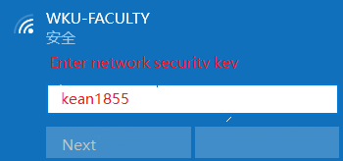

1. Please open a browser (preferably Google Chrome). Go to login.wku.edu.cn (or 5.1.1.24), then an Internet Authentication System page will pop up. Please fill in your Internet username and password, and click “Log in”.

Please visit One-stop Service Center for help if you forget your username or password.

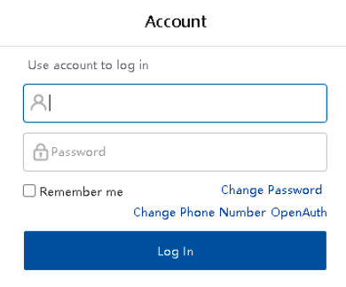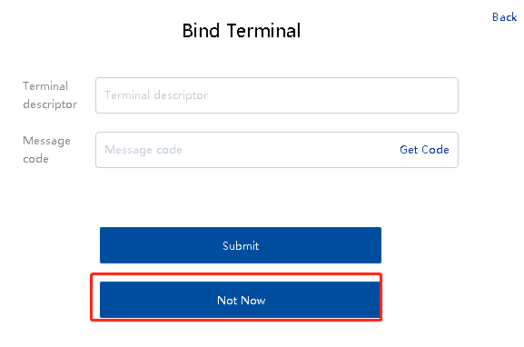

1. You are all set!

**Bind your network account to your devices.**

The network login would not require after you bind your device to your network account.

1. 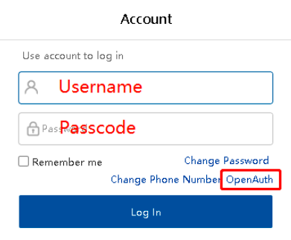 Please ensure your device connect campus WiFi. Then go to 5.1.1.24 or login.wku.edu.cn. Enter your network username and password. Then Click "OpenAuth".
2. Please follow the instruction below to bind your device.

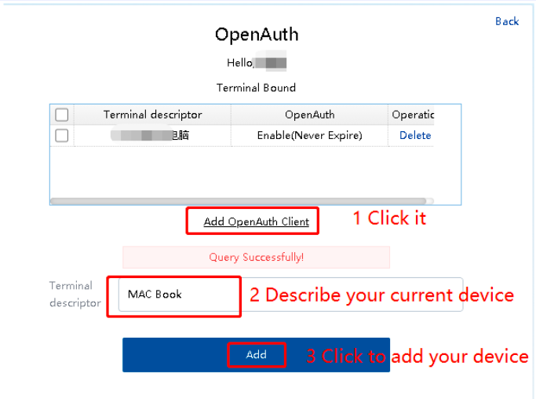

## Cisco VPN for PC (Windows and MAC)

Cisco VPN can be used when you are off campus. Please follow the steps to set up the VPN.

1. Please make sure you are connected to WIFI, then open your Internet Explorer and go to <https://anyconnect.wku.edu.cn> .

2. When you see the error message, please select “Continue to this website” as it is shown below.

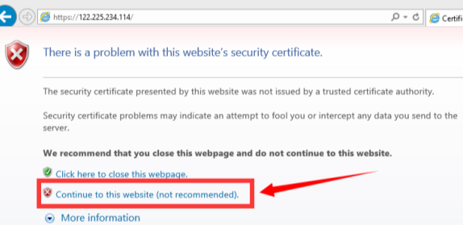

3. Your GROUP is kean. Type in your username and password.

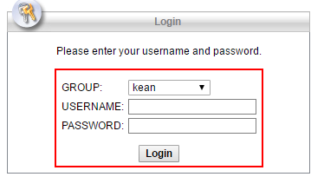

1. You will see as below. Click Download.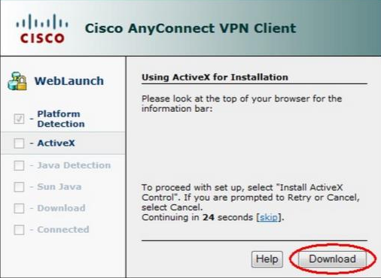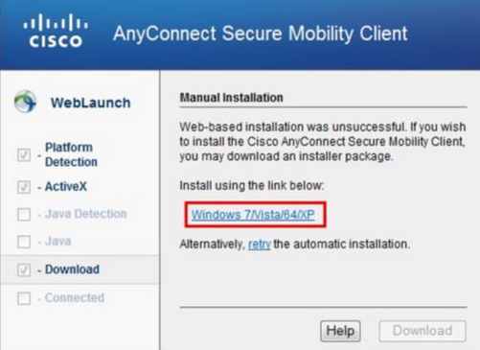

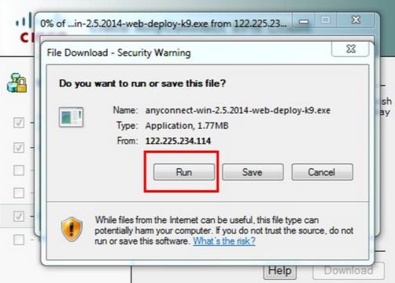5. Save or run this file.

6. Install the software as follows.

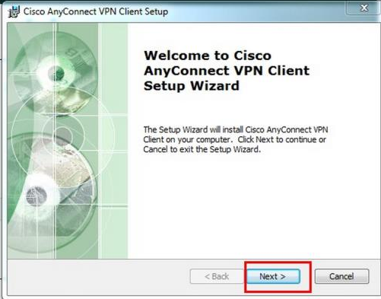

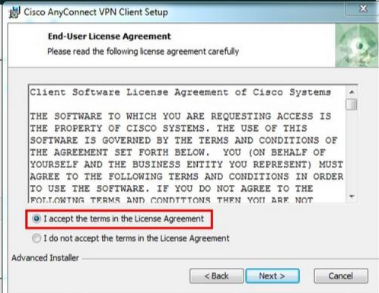

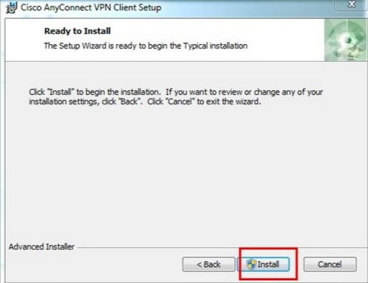

7. After installation, please find and open Cisco AnyConnect in your application menu, check the option and click “Connect Anyway”.

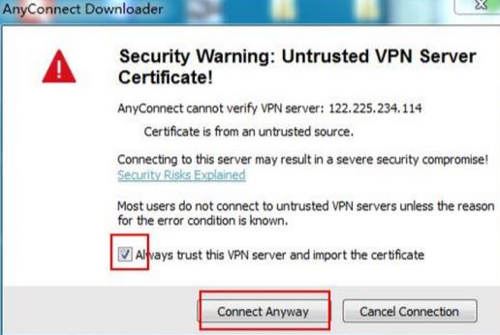

8. Please click the “gear” on the bottom left corner.

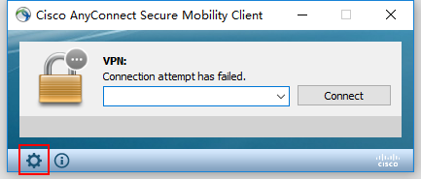

9. Please untick the choices, and exit.

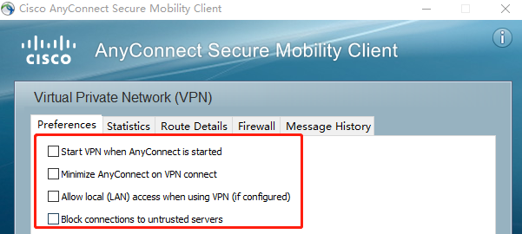

10. Input VPN address: anyconnect.wku.edu.cn. Click “Connect”.

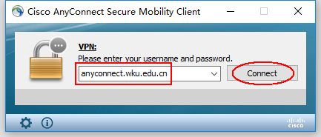

11. Type in your username and password. When it is connected, you can find the icon in the task bar.

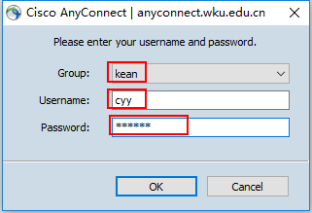

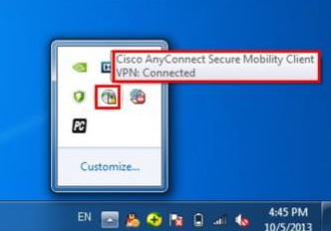

12. You are all set!

## Application for Academic Equipment

1. Login My WKU at <http://www.wku.edu.cn/>, choose OFFICE AUTOMATION.
2. Click the first one “Workflow Apply”.
3. Click “Assets”, then choose “Assets Procurement”.

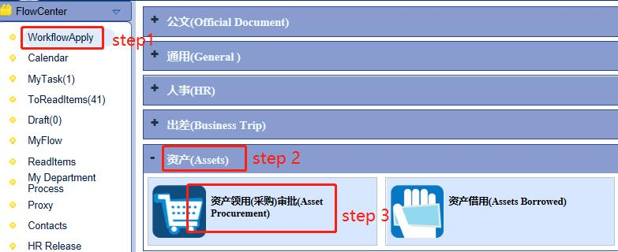

1. Fill out the form as required and submit.
2. The request will be processed by Academic Affairs and Logistics. If approved, the assets will be purchased within a month.

An asset that is worth more than 1000RMB has to be applied in 1-year advance to college assistants. Any questions about your procurement, please find your college assistants. The fund is from your college.

An asset that is worth more than 2000RMB needs to be returned to WKU when employee is not rehired. If there is any damage or loss, the repair amount shall be paid by the user.

For more IT assistance, please visit IT web at <https://wku.kf5.com/hc/kb/article/1250655/>, or visit One-stop Service Center.

# ONE-STOP SERVICE CENTER

Wenzhou-Kean One-stop Service Center, which is located on 2nd floor of General Education Hall (GEH), D Wing, provides daily assistance for faculty and staff. Faculty&staff could report problems like maintenance issues via following ways:

1. Email (recommended): fsoss@wku.edu.cn.
2. Tel: 55870707.
3. Emergencies during the non-working hours: 55870033
4. Visiting one-stop service center GEH 2ND Floor, D Wing. Work hours: 8:30-20:30 on work days.

# APPENDIX

## Residence Permit Q&A

**What should I do with my current visa after I enter China?**

For people who enter China with work visa, you need to transfer the work visa into residence permit within 30 days, since your work visa (Z visa) is only valid for 30 days. Your initial visa (work visa) grants you the right to enter China for a specific purpose, but expires after a month later. If you wish to stay longer in China, you will need to apply for a residence permit which works like a multiple-entry visa, allowing you to leave the country and return without an additional visa as long as the permit remains valid (even if your original visa has expired).

For people who enter China with residence permit**,** you need to renew it before it is expired.

 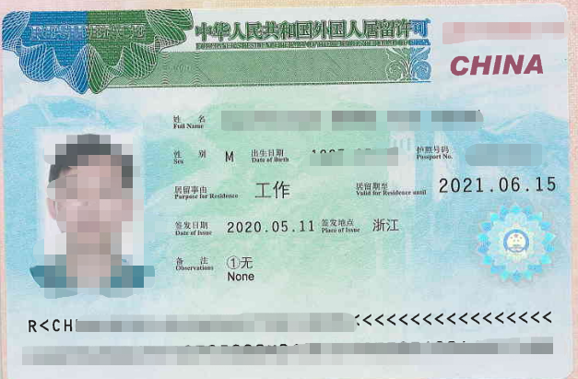

(Work Visa) (Residence Permit)

**How can I transfer my work visa to residence permit visa? Who should I ask for help?**

WKU Human Resources staff will take care of your visa issues. You need to prepare the following required materials for application.

1. A hard copy of your passport page, current visa page, and your latest entry stamp.
2. Health Report. You need do the physical exam in local Health center (HR staff will arrange the physical exam time and send Chinese staff to go with you).
3. A Foreign Expert Certificate (WKU HR will get this for you, and you need to submit all required original materials to HR office).
4. Go to the Police Station to fill out some forms and hand in your passport (HR staff will arrange the time and take you to the police station).

**What about the visa of my family members if they need to stay here with me?**

If they just want a short stay (within their current visa valid date), they do not need to do anything.

If they want a long stay, they need to do above-mentioned steps 1&2&4 as you do. For children under 18 years old, they can skip the physical exam.

Besides, you need to offer your marriage certificate (for spouse) or birth certification (for children/for your parents) and its authentication. You need to bring these original materials to HR ASAP. Because these materials need to be translated into Chinese by official translation association and it takes time.

**How can I renew my residence permit before it expires?**

For the returning faculty of the university, you need to redo the step 1 and 2 in Q2 (since the health report is only valid for 6 months). HR staff will help to renew your Foreign Expert Certificate with your reappointment letter.

For the second year, police station will send staff to the university to help you renew your residence permit visa, which means you do not need to go to the police station like the first time. The policeman will stay one or two days in the university, so please DO renew your visa at that time. If you miss the chance, you’ll have to go to the police station by yourself.

For people who worked in China before (in other provinces), you need to do the visa transfer with your current valid residence permit, besides the step 1 and 2, you also need to prepare a digital photo with a white background, authenticated diploma, diploma, cancelation letter of your previous Foreign Expert Certificate and the recommendation/release letter of your previous school.

**How long does it take to get my passport back after I hand in my passport to the Police Station? Do I need go back to the Police Station to collect my passport?**

Technically, it will be ready for collection in 3 weeks. HR staff will collect the passport for you. You could collect the passport in HR office once you receive an email from HR.

# WKU Health Service Center Office Hours

8:30 AM- 8:30 PM (Office Open)

8:30 AM- 4:30PM on Mon-Fri (Doctor Time)

8:30PM - 8:30AM (Emergency Only)

TEL: 0577-55870120

Location: GEH A109

# Hospital Appointment Hotline

1. 86-021-6060-5180 (Direct Billing Hospital)
2. 114 (Non-Direct Billing Hospital)

# Hospital Addresses

温州医科大学附属第一医院新院区：瓯海区南白象上蔡村

The First Affiliated Hospital of Wenzhou Medical University (Ouhai District)

温州医科大学附属第一医院老院区：鹿城区府学巷2号

The First Affiliated Hospital of Wenzhou Medical University (Lucheng District)

温州医科大学附属第二医院/附属儿童医院：鹿城学院西路109号

The Second Affiliated Hospital of Wenzhou Medical University/Affiliated Children's Hospital: No.109, Xueyuan Road (West)

温州医科大学附属口腔医院：鹿城学院西路113号

Dental Hospital Affiliated to Wenzhou Medical University: No.113, Xueyuan Road (West)

温州医科大学附属口腔医院分院：鹿城广场路183号

Dental Hospital Affiliated to Wenzhou Medical University (Branch): No.183, Guangchang Road

温州医科大学附属眼视光医院：鹿城学院西路82号

Optometry Hospital Affiliated to Wenzhou Medical University: No.82, Xueyuan Road (West)

温州市人民医院（信河院区）：鹿城区五马街道仓后街57号（急诊可注射狂犬疫苗）：

Wenzhou People’s Hospital (Xinhe Branch): No.59, Canghou Street, Wuma Road (Offers rabies vaccine at emergency department of this hospital)

温州市人民医院(娄桥院区)：瓯海区古岸路南侧

Wenzhou People’s Hospital (Louqiao Branch): Gu’an Road(South), Ouhai District

温州市中西医结合医院/温州市儿童医院：鹿城区锦绣路75号

Wenzhou Integrated Traditional Chinese and Western Medicine Hospital/ Wenzhou Children's Hospital: No.75, Jinxiu Road

温州牙科医院：鹿城区府前街197号利府大楼2楼，府前街公交站旁 / 电话：88295678

Wenzhou Dental Hospital: The second floor of Lifu Building, No.197 Fuqian Road, near bus stop of Fuqian Road / Tel.: 88295678

# Addresses of Community Health Service Centers:

(Offer types of vaccinations: rabies, tetanus, flu, COVID-19 ,etc.).

丽岙街道社区卫生服务中心：五社公交站旁，电话：56951569

Liao Street Community Healthcare Center: Next to the Wushe bus stop. Tel: 56951569.

南白象街道社区卫生服务中心：鹅颈头公交站牌旁边，电话：56612635

Nanbaixiang Street Community Healthcare Center: Next to the Ejintou bus stop ，Tel: 56612635.

# Education Options for Kids

**Kindergarten**

**1) WKU Experimental Kindergarten**

WKU Experimental Kindergarten is a private school, and is a 5-min walking distance from WKU campus. The kindergarten has 3 grades and 12 classes, and the courses are taught in both Chinese and English. Each grade has 1 Kean Class, the students of which are the children of WKU employees. Each Kean Class has 1 foreign teacher, 1 Chinese teacher and 1 nurse. All curriculum structure and teaching materials are subject to Kean kindergarten education system.

Tuition fee:  RMB 25,000/ year. WKU employees are entitled 50% discount.

1. **WKU International Kindergarten**

WKU International Kindergarten is a private school locates in Wenzhou downtown, at the beautiful Nantang Riverside, with convenient public transportation. It’s a 20-min driving distance from XTY apartment, and a 30-min driving distance from WKU. The kindergarten has 3 grades and 12 classes. All courses are taught in Chinese.

Tuition fee:  Around RMB 12,000/ year.

**3) Wenzhou No.12 Kindergarten**

Wenzhou No.12 kindergarten is a public kindergarten which locates in Wenzhou downtown. it has 3 grades and 12 classes, and all courses are taught in Chinese. It’s a 10-min walking distance from XTY apartment.

Tuition fee:  Around RMB 10,000/ year.

**4) Shanghai United International School-Wenzhou Campus** (<https://wenzhou-en.suis.com.cn/>)

Shanghai United International School-Wenzhou Campus is a private school which was built and donated by Semir Group, and is under the supervision of the Shanghai Xiehe Education Group. It is a K-12 boarding and day school with an affiliated kindergarten, a primary school, a middle school and a high school. The kindergarten offers bilingual teaching with the concept of "East Meets West". The school is about a 30-min driving distance from WKU.

Tuition fee: RMB 45,000/year.

**Primary School, Middle School& High School**

**1) Wenzhou Xin Tian Yuan Primary School**

Wenzhou Xin Tian Yuan Primary School is a public school which is under the direct administration of Education Bureau of Wenzhou Lucheng District. All courses are taught in Chinese. The school locates in Wenzhou downtown, and is about a 10-min walking distance from XTY apartment.

Tuition fee:  Free

**2) Li’ao No.2 Primary School**

Li’ao No.2 Primary School is a public school in Li’ao Town. All courses are taught in Chinese. The school is about a 10-min driving distance from WKU campus.

Tuition fee:  Free

**3) Wenzhou Union International School** (Email: [admissions@zwuis.org](mailto:admissions@zwuis.org))

As the only school in Wenzhou to offer foreign education at the primary and secondary level, WUIS welcomes applicants for Grade 1 to 8 programs including the children of foreign nationals, residents of Hong Kong, Macau and Taiwan, and overseas Chinese. The school is delivering an International curriculum grounded in the Common Core State Standards of the United States and enhanced by Canadian Curriculum. It also offers Chinese language and culture programs for a better understanding of China and Wenzhou. The WUIS is inside Peking University New Century School – Wenzhou, and is bout five minutes of driving distance from Wenzhou-Kean University.

Tuition fee: RMB 72000/year for Grade 1 to 5. WKU employees are entitled 50% discount.

RMB 76000/year for Grade 6 to 8. WKU employees are entitled 50% discount.

**4) Peking University New Century School-Wenzhou campus**（<http://www.pkuwz.net/en/>）

Peking University New Century School–Wenzhou campus is a full-time private school under the direct administration of Wenzhou Education Bureau. The school has an elementary school and a middle school, and has more than 2,600 students. All courses are taught in Chinese. It’s about a 10-min driving distance from the WKU campus.

Tuition fee for the primary school: RMB 42,000/year. WKU employees are entitled 50% discount.

Tuition fee for the middle school: RMB 40,000/year. WKU employees are entitled 50% discount.

**5) Shanghai United International School-Wenzhou Campus** （<https://wenzhou-en.suis.com.cn/>）

Shanghai United International School-Wenzhou Campus is a private school which was built and donated by Semir Group, and is under the supervision of the Shanghai Xiehe Education Group. It is a K-12 boarding and day school with an affiliated kindergarten, a primary school, a middle school and a high school.

The elementary school and the primary school follows the Bilingual Curriculum (SUIS Pioneer) informed by the best of Chinese and Western pedagogies. After graduation, students can follow one out of four pathways: continue into our secondary curriculum, attend a local secondary school, other international school, or even study abroad.

The High School offers a rich curriculum for students to choose from. The majority of the lessons will be taught in English by expert international teachers or co-taught by Chinese and Western staff. The school is about a 30-min driving distance from WKU.

Tuition fee for the primary school: RMB 60,000/year.

Tuition fee for the middle school: RMB 68,000/year.

Tuition fee for the high school: RMB 98,000/year.

**6)Wenzhou No.2 Foreign Language School**

Wenzhou No.2 Foreign Language School is one of the “Top Ten Schools of 21st Century” authorized by Wenzhou Municipal People’s Government. It’s a boarding public school under the direct administration of Wenzhou Education Bureau, and is a key first-class high school in Zhejiang Province. The school has a middle school and a high school. All courses are taught in Chinese. The school is adjacent to Wenzhou University town, and is about a 20-min driving distance from WKU.

Tuition fee:  Free

**7) Canadian Secondary Wenzhou No.22**

In 2006, the school received approval from Zhejiang Provincial Department of Education and China Ministry of Education to operate a Sino-Canadian Joint High School Program, named Canadian Secondary Wenzhou No. 22. It is the first public school of its kind to run a state approved Sino-Canadian program. The program has also been certified by BC Ministry of Education, Canada. Since the launch of this program, CSW has been very successful. It has introduced a different educational approach, contributing to the diversification of education in Wenzhou, and it has become a good platform for educational exchanges. What’s more, it has helped meet the demand of local citizens for quality international education. It is a three-year high school program with small class size (within the student population of 30). Graduates will receive both Chinese and Canadian high school diplomas based on the condition of meeting all graduation requirements. With Canadian high school diploma, graduates can apply for all universities from different English- speaking countries, such as Canada, America, UK, Australia and so on.

All the courses are taught in English with native British High School Teaching Methods. Graduates can apply for any Canadian universities as well as other universities in English-speaking countries with three-year high school marks.

It’s about a 42-min driving distance from WKU, and a 5-min driving distance from XTY apartment.

Tuition fee: RMB 70,000/year.