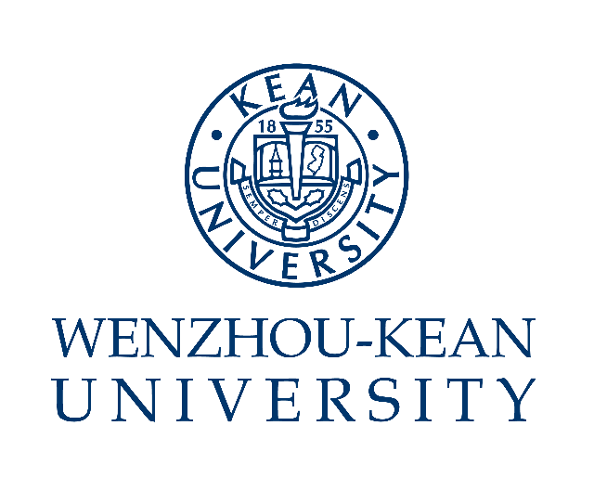
VERIFICATION

This is to certify that *** (Male/Female, Student ID: ***), born on ***eg.June 7, 1999, studies at Wenzhou-Kean University with a major in *** from September, 2018 to July, 2022. It is a full-time, four-year fully English taught Undergraduate program leading to a Bachelor’s Degree.

This student has completed all the required Undergraduate courses and met the graduation requirements. It is expected that the student will obtain the graduation certificate and bachelor's degree certificate in July 2022.

Office of the Registrar
Wenzhou-Kean University
Date: **** eg. June 20, 2022

